GNU Octave, version 3.8.2
Copyright (C) 2014 John W. Eaton and others.
This is free software; see the source code for copying conditions.
There is ABSOLUTELY NO WARRANTY; not even for MERCHANTABILITY or
FITNESS FOR A PARTICULAR PURPOSE. For details, type 'warranty'.

Octave was configured for "i586-pc-linux-gnu".

Additional information about Octave is available at http://www.octave.org.

Please contribute if you find this software useful.
For more information, visit http://www.octave.org/get-involved.html

Read http://www.octave.org/bugs.html to learn how to submit bug reports.
For information about changes from previous versions, type 'news'.

a = 1.000000
l = 1.000000
T = 0.050000

ε =
1.0000e-12

Параметры сетки:
n = 16
k = 8

hx = 0.062500
ht = 0.006250

Начальное возмущение =
@(x) 0.5 * x * (1 – x)

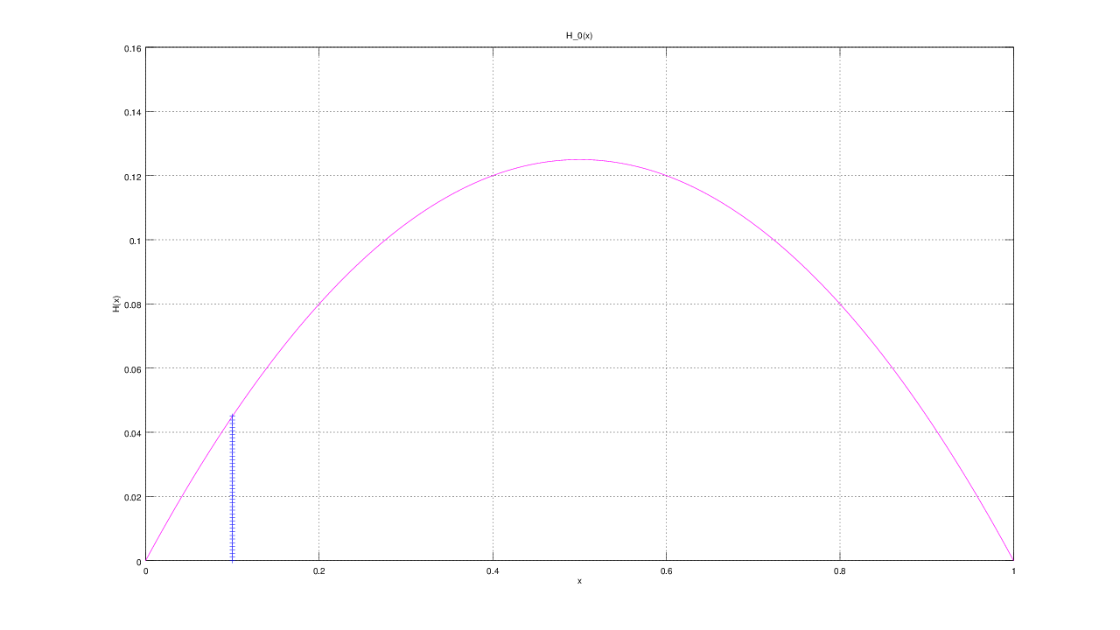

Всего демпферов: 1

Демпфер # 1

x_1 = 0.100000

Верхнее предельное значение w_1(t) =
NaN

Нижнее предельное значение w_1(t) =
NaN

Управляющая функция w_1(t):
-68.2741
102.1401
-62.4882
62.6773
4.1469
-17.6208
80.3552
-128.6328
194.2731

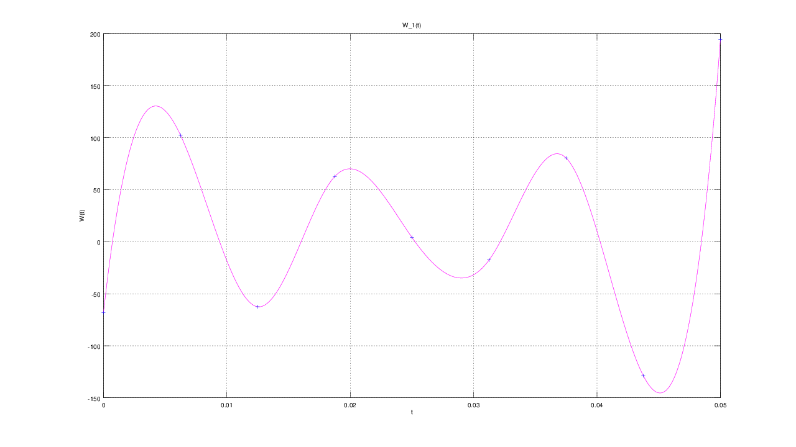

E(T) =
0.13856

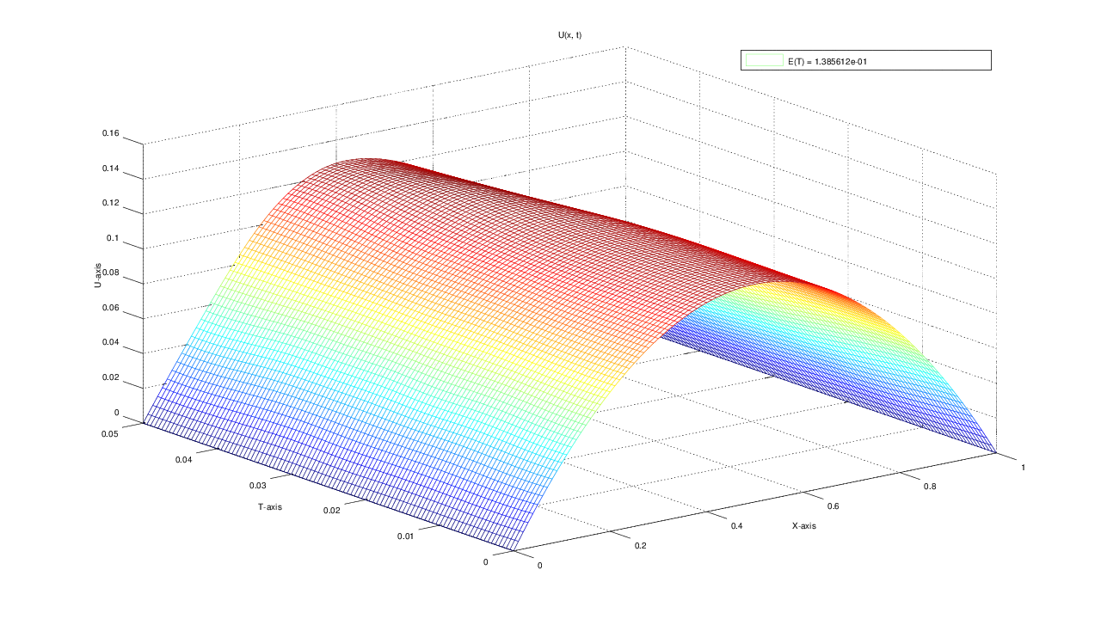

u(x, t)
T = 0.000000: 0.000000 0.029297 0.054688 0.076172 0.093750 0.107422 0.117188 0.123047 0.125000 0.123047 0.117188 0.107422 0.093750 0.076172 0.054688 0.029297 0.000000
T = 0.006250: 0.000000 0.028986 0.055440 0.076716 0.093956 0.107450 0.117165 0.123026 0.124994 0.123062 0.117231 0.107478 0.093713 0.075758 0.053491 0.027440 0.000000
T = 0.012500: 0.000000 0.030005 0.056687 0.078144 0.094897 0.107787 0.117153 0.122936 0.124985 0.123196 0.117455 0.107510 0.092960 0.073623 0.050317 0.025253 0.000000
T = 0.018750: 0.000000 0.029937 0.056425 0.078879 0.096275 0.108879 0.117604 0.123027 0.125142 0.123539 0.117558 0.106513 0.090269 0.069954 0.047664 0.024457 0.000000
T = 0.025000: 0.000000 0.030161 0.057805 0.079357 0.096948 0.110205 0.119072 0.124196 0.125885 0.123531 0.116117 0.103366 0.086457 0.067185 0.046159 0.023257 0.000000
T = 0.031250: 0.000000 0.030858 0.057755 0.080452 0.097791 0.111358 0.121203 0.126573 0.126938 0.122119 0.112522 0.099294 0.083482 0.065087 0.044208 0.022392 0.000000
T = 0.037500: 0.000000 0.030261 0.057897 0.080729 0.099628 0.113753 0.123469 0.128100 0.126655 0.119681 0.109054 0.096032 0.080414 0.062217 0.042588 0.021715 0.000000
T = 0.043750: 0.000000 0.028353 0.055944 0.080862 0.101403 0.116770 0.125387 0.127591 0.124671 0.117664 0.107029 0.093061 0.076811 0.059492 0.040792 0.020641 0.000000
T = 0.050000: 0.000000 0.028098 0.055052 0.080693 0.102262 0.117376 0.125432 0.126813 0.123243 0.115825 0.104625 0.090375 0.074347 0.056823 0.038231 0.019379 0.000000

